Intro To DBS
LEC#3
Storage Hierarchy
Disk->Files/directories->pages/blocks->tuples(rows)->fields
Physical disk stores files for tables. Each table starts out with one file and expands if needed.
Each table contains one or multiple pages/blocks which are expanded when needed.
The pages contain rows of data and metadata.
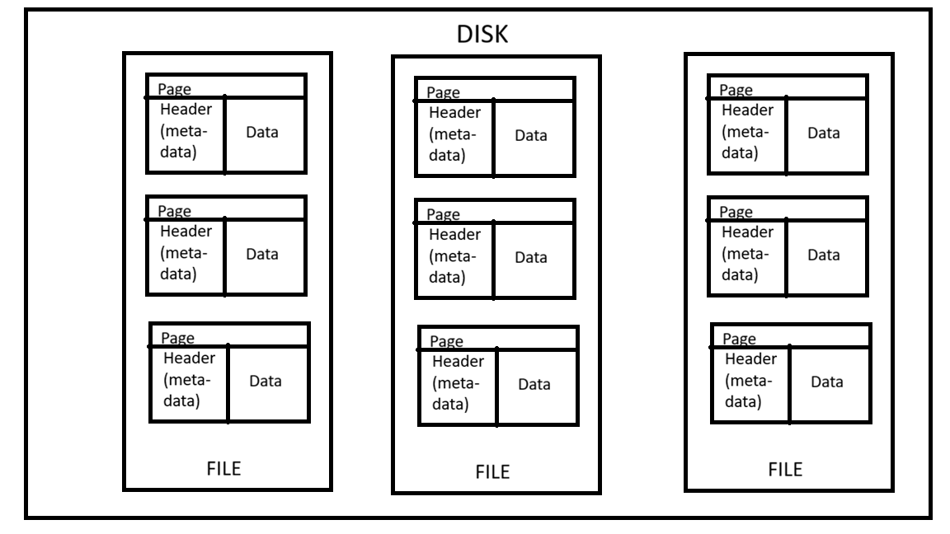
Tuple Oriented Storage
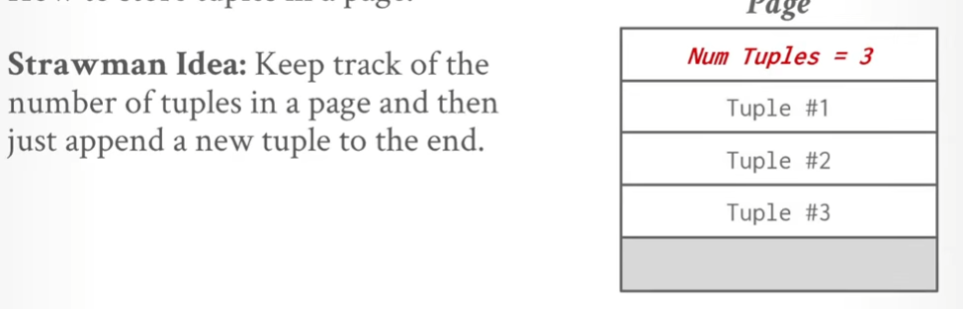
Delete a tuple and add a new tuple
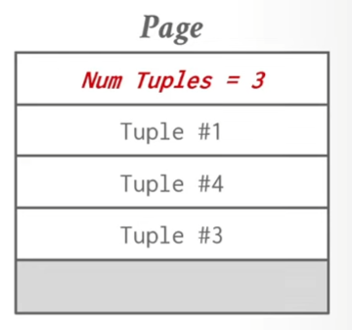
This is no longer sequential. Also what will happen if we have variable length of tuples?
Slotted Pages
Map slots to the starting location offsets of the tuple
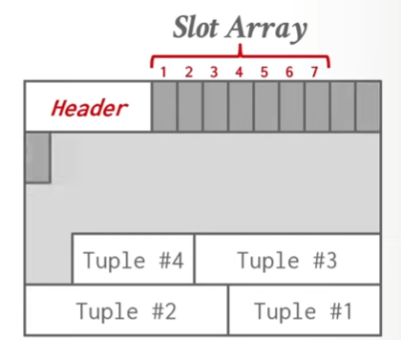
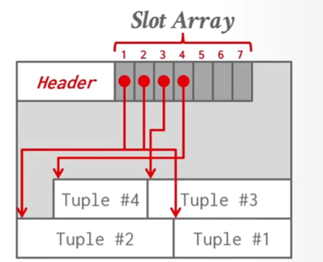
If you delete tuple 3 just push back tuple 4 and update the offset in the slot array according to the new location
ENSURES NO EXTRA UPDATES REQUIRED OUTSIDE OF THE PAGE
Issue; How to map logical location of the tuple to its physical location?
Record IDS
Unique identifier that represents the physical location within the database of a logical tuple for example (fileid,pageid,slotid)
FYI: files, pages and tuples all have headers that store different types of metadata
Tuple Layout
Byte array followed by a header(metadata about the data in the tuple itself)

Tuple Data
Attributes typically stored in the order by which they are defined
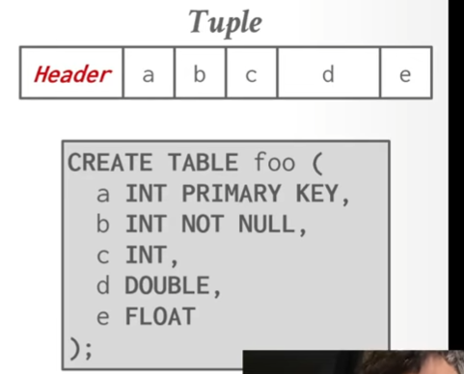

Data Access

- Get offset to tuple by looking up the slot array
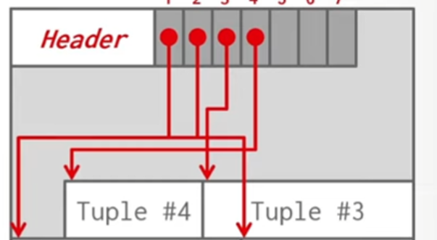

- Jump over the header to get to the attribute
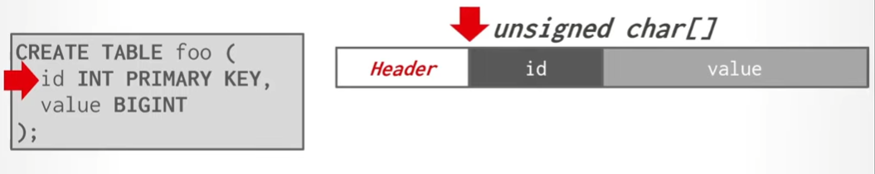
- Convert the address into a 32bit integer


Issue: As attributes are stored in sequential order, if the attribute being stored exceeds the word limit it will span onto two words. We must access two words to get a single attribute which is not efficient.
FIX: -
Word aligned Tuples
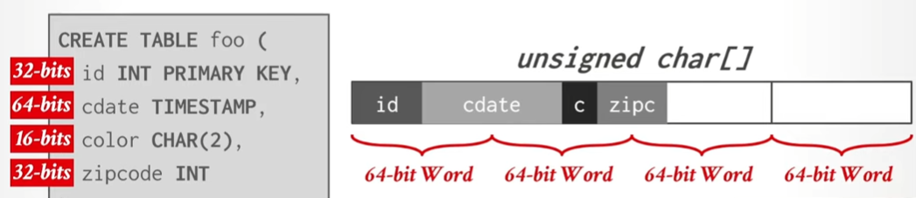
Accessing cdate can cause compiler errors or extra computation(accessing 2 words).
To fix this just pad
Word alignment – Padding
Add empty bits after attribute to ensure tuple is word aligned
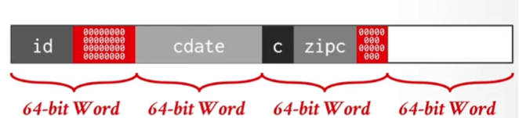
Id =0
Cdate =64
C = 128
And so on
CAN WASTE SPACE
Word alignment – Reordering
Arrange to fix word size
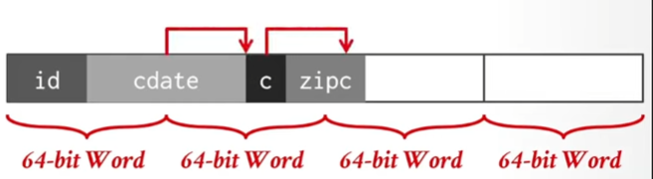
arrange
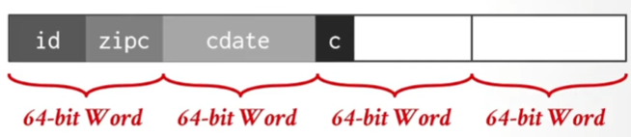

Little vs big endian
Byte Storage techniques
Big= biggest->smallest bit
Little = smallest->biggest bit

